

**American International University- Bangladesh**

Object Oriented Programming 2

Project Proposal

Group No: 1

Project Title: Wallet Buddy

Members:

|  |  |
| --- | --- |
| **Student Name** | **Student ID** |
| Tanjila Rahman | 17-35439-3 |
| Mahmudul Hasan Anik | 18-36731-1 |
| Md Tanzeem Rahat | 18-37780-2 |

**Wallet Buddy**

**Introduction:**

Presently there is a rapid growth of commodities and necessities in our day-to-day life as more and more services are added to the list of our daily needs. But keeping track of all the expenditures in different sectors can be sometimes an overwhelming task. So, the aim of our project is to address this issue and design a system to keep track of the expenditures and incomes on daily, weekly, monthly and/or yearly basis. It will also enable a user to keep record of different accounts and balances available. We also intend to implement record keeping systems where the history of transactions, loans or lends can be saved as well. This project will define a basic design which can be further extended with advanced functionalities.

**User Category:**

There will be mainly 2 types of users in this system. Those are:

* Application user
* Admin

**User Feature lists:**

The “application user” will have the following features:

* Log in, change login details
* Add/Remove different money handling account
* Add/Remove balance to different accounts
* Add/Remove expenditure in different sectors
* Set daily/weekly/monthly/yearly budget plan
* Check the expenditure history
* Add payment deadlines
* Transfer balance between accounts
* Check how much is spent of the target budget
* Add deadlines for bill/loan payments

The “admin” will have the following features:

* Act as the super user for data handling
* Help users to validate information in case of forgotten credentials
* Maintain data integrity in database
* Add/remove users
* Check the list of all users and their account credentials
* Act as a support for any specific user requests.

**Use cases for Application user:**

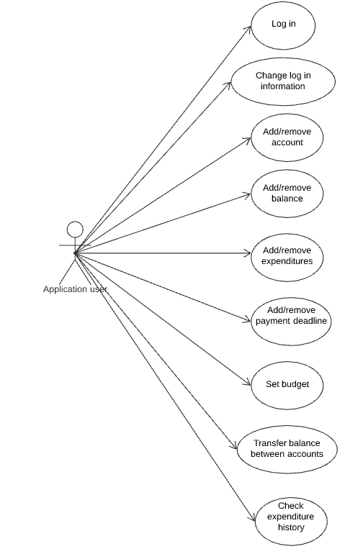

**Fields for Application user:**

* name : string
* id : string
* password: string
* balance: double
* moneyAccounts[] : MoneyAccount
* History : Stack<Transaction>
* transactions[]: Transaction
* deadlines[]: Date
* Loans[]: Loan

**Use cases for Admin:**

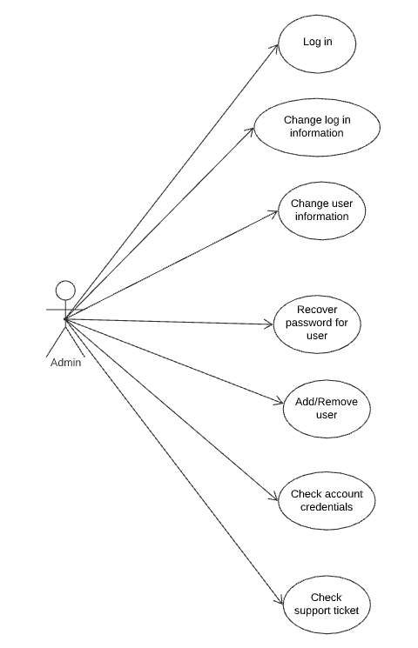

**Fields for Application user:**

* name : string
* id : string
* password: string
* tickets[]: Ticket

These are the proposed features and users of the system we are planning to design. This is just the basic outline and is subject to changes throughout the development process.